Chapter 10: Land, Public and Private

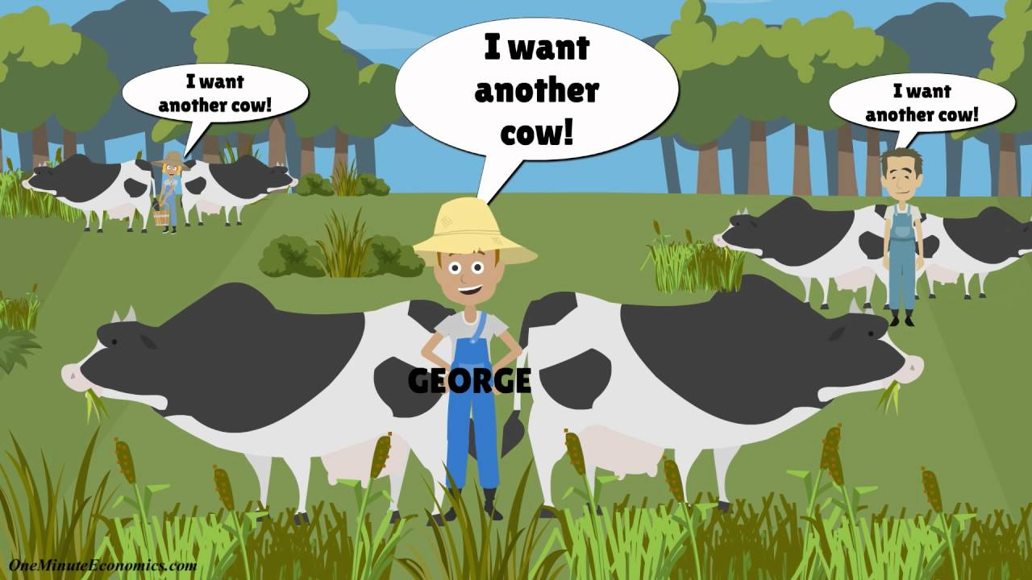

Can you….

1. Explain in your own terms tragedy of the commons with examples?
2. Describe what maximum sustainable yield is?
3. Identify the “extremes” in public land ownership around the world and what it’s used for?
4. Identify the different Acts and what they were designed to do?
5. Compare different techniques for tree harvesting?
6. Describe what happened with the Yellowstone National Park fires and the effects it had on the environment?
7. Compare and contrast the four agencies that manage public lands in the United States?
8. Identify causes of urban sprawl?
9. Explain the concept of prescribed burns and why they are important?
10. Identify IUCN and what it’s known for?
11. Describe how climate change can affect the environment?
12. Read and understand a biosphere reserve map?
13. Explain where we stand on extinction today and why?